**Physics In the Universe** Name: Dessa Shapiro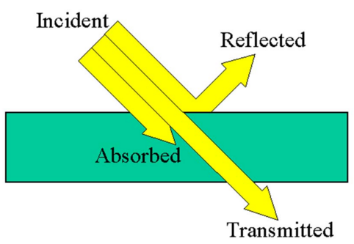

**Properties of Light Lab** Class Period: 3

(At Home Version)

**Background Research:**

| **Vocabulary Term** | Your composite definition: Construct your own definition of the work in your terms. You will need to pull from multiple sources. Please don’t be a cheater-head and grab something from the internet without thinking about it | A Contextual Anchor |
| --- | --- | --- |
| Light | Energy to which the organs of sight react, ranging in wavelength from about 400 to 700 nanometers and propagated at a speed of 186,282 miles per second (299,972 kilometers per second), considered variously as a wave, a stream of particles, or a quantum phenomenon. | The Physics of Light - YouTube |
| Electromagnetic Radiation | radiation consisting of electromagnetic waves, including radio waves, infrared, visible light, ultraviolet, x-rays, and gamma rays. | What Is Electromagnetic Radiation? | Live Science |
| Absorption | how matter takes up a photon's energy — and so transforms electromagnetic energy into internal energy of the absorber. A notable effect is to gradually reduce the intensity of light waves as they propagate through a medium. | Absorption | physics | Britannica |
| Reflection | the act of reflecting, as in casting back a light or heat, mirroring, or giving back or showing an image; the state of being reflected in this way. | The Law of Reflection | Physics |
| Refraction | the change in direction (bending of light rays) when it passes from one optically transparent medium to another. | Is refraction sharp or smooth? - Physics Stack Exchange |
| Diffraction | the bending or spreading out of waves when they travel through a small opening or when they pass round a small obstacle. | 3.5.3. Diffraction of waves - PGS Physics |
| Intensity | the power transferred per unit area, where the area is measured on the plane perpendicular to the direction of propagation of the energy. In the SI system, it has units watts per square metre. | Intensity (physics) - Simple English Wikipedia, the free encyclopedia |
| Transparent | having the property of transmitting rays of light through its substance so that bodies situated beyond or behind can be distinctly seen. | Transparent, Translucent & Opaque Poster | Light science, 6th grade  science, First grade science |
| Opaque | Not reflecting light; having no luster: an opaque finish; Impenetrable by light; neither transparent or translucent. | Transparent, Translucent & Opaque Objects - YouTube |

**Station One: Absorption of Light**

|  | Transparent Red Plastic | Transparent Green Plastic | Opaque Red Plastic | Opaque Green Plastic |
| --- | --- | --- | --- | --- |
| Red Laser Beam | The laser went straight through the plastic and there were no signs or light interference | The laser was stopped by the plastic no singines of any light on the blocked side or scattering | Light was blocked but unlike the green it was more refracted/ scattered and could be seen dispersed through the blocked section and some seen in the empty section | Similar to transparent green all light blocked from the other side but on the Lazer size there was more light scattered on the closed off side. |
| Green Laser Beam | Completely blocked by plastic little to no reflection or refraction | straight through the plastic and there were no signs or light interference | One side blocked off and no sign of light interference or any change in laser- absorption very small scatter of light on laser side | The beam or the laser was blocked but the light still filled the blocked section and on the laser section the light was more dispersed |

**Station Two: Reflection of Light**

|  | Observations in words | Sketch of Observations |
| --- | --- | --- |
| Mirrors | With one mirror the word is flipped to look as if the letters are backwards and reversed and with 2 mirrors the word looks the same as it does originally- flipped twice |  |
| Angle of Light | On this surface as the angle of light changes and reflects it makes 2 vertical angles that are congruent and change with each other. The other 2 diagonal angles are also congruent. |  |
| Two Pencils and a mirror | Amroxamentally 75% of the base of a pencil( the tip is not visible) is reflected in a mirror and another pencil is added behind the mirror so it´s top half is showing and when lined up this creates an illusion that there is a single pencil but it reality the seconde pencil is much taller than the first so the mirror had effect on perspective. |  |

* **Pro Tip:** You can draw what you see on paper and then take a tightly cropped photo and insert it into the table if you don’t make the picture too large!

**Station Three:Refraction of Light**

|  | Observations in words | Sketch of Observations |
| --- | --- | --- |
| Light through half sphere | Through half a sphere the light first goes through the sphere and when it leaves the object it is more powerful/brighter and is refracted at a slightly different angle. There is also another light ray reflected but more dispersed back towards the original source |  |
| Light through box w/ air | Light goes directly through the box in a straight line. Another less prominent ray is reflected off the box surface. There are some reflections of original light rays seen on the base of the box. |  |
| Light through box w/ water | The light is refracted as it touches the box and changes direction and does not look like a straight clear line. It is more scattered and there is one main exit point. This is also a reflection as the light hits the box surface. And it illuminates the whole box making it colored |  |

Reflection Questions

* With the half sphere we can bend the laser beam. Why does the beam bend different amounts as we move the sphere side to side in front of the beam?

<The beam bends different amounts as moved because the circular shapes of the sphere directs the light in a different angle, so the more rounded the sphere is the sharper the light angel gets.

* By comparing how an empty box affects the beam to how a box with water affects the beam, we can learn something. What else do you think we can try and compare?

I think we could compare these two boxes with other substances such as a certain type of gas or a thicker liquid to see how the light would react. You could also change the color or material of the box the see different results.

**Station 4: Diffraction of Light**

|  | Observations in words | Sketch of Observations |
| --- | --- | --- |
| Light through two pencils | When light is put between the two pencils you can see small spaces in between the line or light coming from the centerpoint(brightest point) of the light. And the spaces the look like dashes disappear as the distance from the centerpoint decreases and the light becomes less bright |  |

Reflection Question

* How does this demonstration show that light must be a wave?

This shows that light must be a wave because you can see the diffraction in the form of the dashes of more concentrated light. These dashed indicate a spreading of light in a ripple/wave like motion because you can see the levels of light fluctuating in wave-like motions.

**Station 5: Intensity of Light**

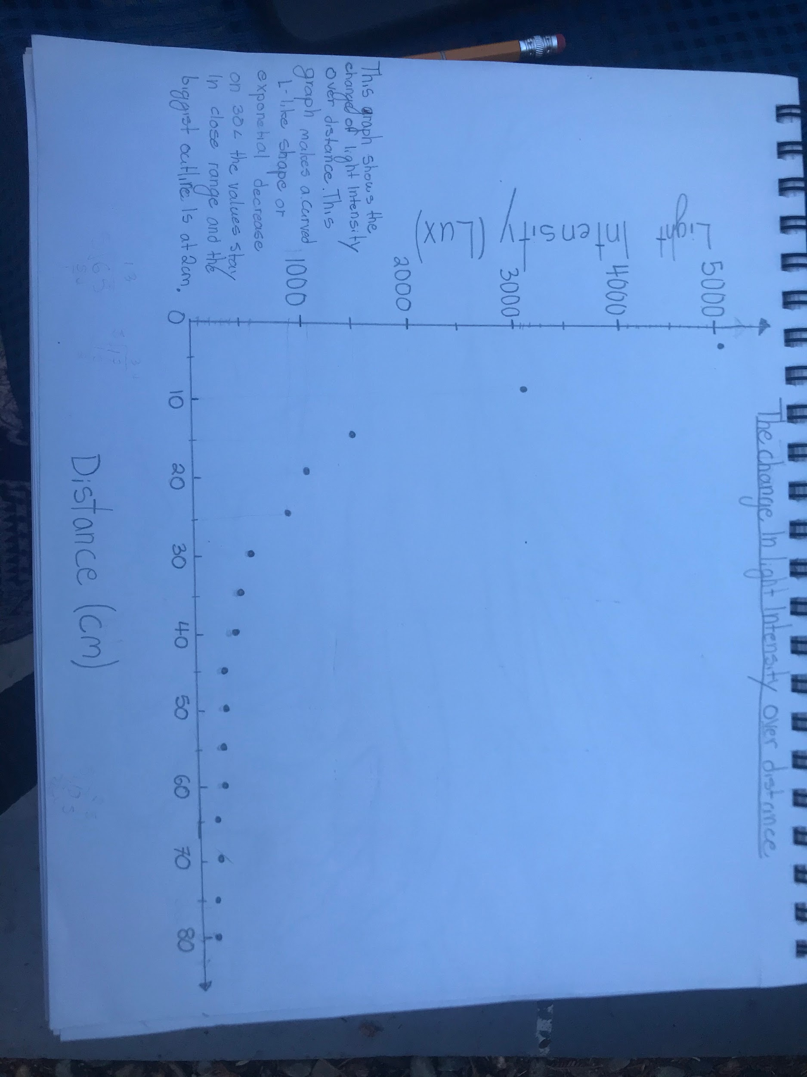

| Light Internisty (LUX) | Distance (CM) |
| --- | --- |
| 5127 | 5 |
| 3282 | 10 |
| 1524 | 15 |
| 1151 | 20 |
| 937 | 25 |
| 628 | 30 |
| 549 | 35 |
| 484 | 40 |
| 303 | 45 |
| 362 | 50 |
| 308 | 55 |
| 300 | 60 |
| 262 | 65 |
| 288 | 70 |
| 233 | 75 |

| 232 | 80 |
| --- | --- |

**Data Analysis**

Now it’s time to process what you observed. You may need to go back to each video in order to analyze your observations well, that’s OK!

**Station 1: Absorption of Light**

1. What is a general rule that you can come up with via your observations in this station?

Light will be absorbed by it’s complementary color and more opaque objects are more adsorbent.

**Station 2: Reflection of Light**

1. We have all seen how words get reversed in a mirror. What happens in two mirrors?

With two mirrors the word is getting reversed with the first mirror looking flipped, but when you add a second mirror you are reversing it again returning it so it looks like the original image.

1. Look at the angle of the light beam as it approaches and leaves the mirror. Can you make a rule about these angles?

These two angles are vertical and congruent(the same) and will stay congruent when moved.

1. With the pencils, is there a rule you can make about where the image of the pencil appears to be compared to where it actually is?

The image of the pencil looks as if it is directly behind the mirror when it is actually farther away. A reflected image on a mirror changes the depth perception and can make objects look a different distance than they are.

1. The purpose of this lab is to understand the properties of light. Is there some general property of light that all of these observations confirm? Hint: what kind of a path does the light travel in for all these examples?

For these labs and experiments I found that light travels in straight lines and angles. I came up with this because in these labs the light always perfectly reflects either giving a reverse image or changing perception.

**Station 3: Refraction of Light**

1. With the half sphere we can bend the laser beam, why does the beam bend different amounts as we move the sphere side to side in front of the beam?

The light bends different amounts because the further you move the light the bigger the curve of the circle is and the curve moves the light causing a refraction.

1. What did you learn by comparing how a box filled with air vs. water affects a beam of light? Why do you think that this happens?

I learned that in the box of water the light was much more dispersed than the box of air. I think this is because the molecules of a liquid are closer together and slower so there is less space for the light to go in a straight line.

**Station 4: Diffraction of Light**

1. In this station we were bending and separating the laser beam, but the beam isn’t passing through any substance other than air. Can you explain why this experiment shows that light must be a wave?

This shows light must be a wave because when its diffracted the spreading of the light waves are visible in a line, and I could see the lights density fluctuations which shows the light dispersion.

**Station 5: Light Intensity**

1. What did you discover about light intensity and distance? Look at your graph. What kind of relationship do you see?

Light intensity decreases over distance and the change of light intensity is bigger when closest to the light and at further distances the change is smaller. I see a nonlinear relationship in the graph that makes a reverse exponential curve.